MINI PROJECT-2

(2019-2020)

Online Food Ordering System

PROJECT REPORT



Institute Of Engineering And Technology

Abhishek Kumar Singh(171500011)

Anuj Saxena(171500055)

Ayush Mittal(171500076)

Supervised By:

Mr. Mandeep Singh

Technical Trainer

Department Of Computer Science And Application

**DECLARATION**

We hereby declare that the project work entitled “Online Food Ordering System**”** submitted to the GLA University Mathura, is a record of an original work done by me and my team under the guidance of Mr. Mandeep Singh**,** Mentor of our Project.

Signature of Candidate:

Name of candidate: Abhishek Kumar Singh , Anuj Saxena , Ayush Mittal

Roll. No.: 171500011, 171500055, 171500076

Course: Computer Science and Engineering Year: III

Year: 3rd Year

Semester: VI Semester

**Certificate**

This is to certify that the project entitled , “**Online Food Ordering System”** designed on Full stack is an original work carried out by **Abhishek Kumar Singh, Anuj Saxena , Ayush Mittal** of Bachelor of Technology (Computer Science & Engineering) during semester VI from **GLA University**, Mathura under the supervision **Mr. Mandeep Singh.**

The matter embodied in this project is a genuine work done by the students and has not submitted to any other university for the fulfilment of the requirement of any course of study.

**Date : Mr. Mandeep Singh**

**ACKNOWLEDGEMENT**

We have taken efforts in this project. However, it would not have been possible without the kind support and help of many individuals. On the completion of this project we would like to extend my sincere thanks to all of them. I am highly indebted to this project mentor Mr. Mandeep Singh, Technical Trainer for their guidance and constant supervision as well as for providing necessary information regarding the project. We wish to extend our sincere gratitude to Prof. Anand Singh Jalal, Head of Department of Computer Engineering and Applications and faculty of CEA Department of GLA University for their guidance, encouragement and give this opportunity and valuable suggestion which prove extremely useful and helpful in completion of this synopsis. We would also like to thank all those who directly or indirectly supported or helped me. We would like to express our gratitude towards our parents and member of our college for their kind cooperation and encouragement which helped us in completion of this project. All of them have willingly helped us out with their abilities.

Abhishek Kumar Singh(171500011)

Anuj Saxena(171500055)

Ayush Mittal(171500076)

**ABSTRACT**

The objective of the project is to design Online Food Ordering System which enables the admin to keep the record of the Hotel and the customers.

This Project is designed through Web technology and consists of a SQL server which acts as the database for the project.

Our motivation for the project came from our enthusiasm and strong urge to learn Full Stack with PHP which is one of the growing technologies in today’s world. The Online Food Ordering System mainly consists of two types of users. The customers who access the information provided by the system and the administrator who modifies and updates the information.

The system is implemented using a 3-tier approach, with a backend database, a middle tier of apache and PHP, and a web browser as the front end client. In order to develop a Online Food Ordering System, a number of technologies must be studied and understood. These include multi-tired architecture, server and client side scripting technologies, implementation technologies like PHP, and relational databases (such as MySQL).

**CONTENTS**

Acknowledgement..........................................................................................................................iv

Abstract............................................................................................................................................v

1. Introduction................................................................................................................................08

1.1Problem Statement........................................................................................................08

1.2 Aim & Objective....................................................................................................08-09

1.3 Existing System...........................................................................................................09

1.4 Proposed System..........................................................................................................09

1.5 Hardware Requirements...............................................................................................09

1.6 Software Requirements................................................................................................09

2. Technology Used.......................................................................................................................10

2.1 HTML..........................................................................................................................10

2.2 CSS..............................................................................................................................11

2.3 JS..................................................................................................................................12

2.4 BOOTSTRAP 4......................................................................................................12-13

2.5 PHP..............................................................................................................................13

3. Feasibility Study........................................................................................................................14

3.1 Technical Feasibility...................................................................................................14

3.2 Operational Feasibility................................................................................................14

3.3 Cost Benefit Analysis..................................................................................................15

4. Methodology..............................................................................................................................16

4.1 Planning.......................................................................................................................16

4.2 System Analysis...........................................................................................................16

4.3 System Design.............................................................................................................17

4.4 Implementation............................................................................................................17

5. Software Design.........................................................................................................................18

5.1 User Case Diagram......................................................................................................18

5.2 Sequence Diagram.......................................................................................................19

6. Sample Code..............................................................................................................................20

6.1 Index Page..............................................................................................................20-25

6.2 Home Page..............................................................................................................25-27

7. User Interface.............................................................................................................................28

7.1 Home Page...................................................................................................................28

7.2 About us.......................................................................................................................28

7.3 Contact us.....................................................................................................................29

7.4 Login Form..................................................................................................................29

7.5 Registration Form........................................................................................................30

8. Conclusion.................................................................................................................................31

9.Bibliography...............................................................................................................................32

**1. INTRODUCTION**

This project entitled with Online Food Ordering System. This application developed using web applications.

The Online Food Ordering System is a food cooperative website or application for customers for providing more interactive menu so that the ordering process can be carried out. Ordering food online is designed for its more flexibility and performance, application are make sure that the system has enough navigation function through the picture information or significant logo to guide customer like students follow the steps to finish the ordering food process, apart from that it has been constructed to dealing with large number of orders simultaneously to prevent the food overload. Basically , this online food ordering project illustrates how to supervise for good performance and better services to the user.

This application helps the restaurants to do all functionalities more accurately and faster way. Food Ordering System reduces manual works and improves efficiency of restaurants. This application is helping food ordering to maintain the stock and cash flows ,etc.

The main goal is to maintain the restaurants functions in an effective and accurate manner and also it is reducing the use of manual entries. This application helps food orders to maintain day to day records in system. It is keeping a proper record of the database.

**1.1 Problem Statement :**

Many restaurants are storing all of their data in manual way. They have huge number of customers daily . So because large number of customers , they need the help of some features so they can maintain and stores the records accurately. And providing food online is one of the major issues for them. Such restaurants have less customers base as nowadays, everyone is too busy in there work so everyone want food delivery. But with the help of proposed system customers can get food on home delivery and restaurants can maintain a record of their customer as well.

**1.2 Aim &Objective :**

The main objective of the project on Online Food Ordering System is to manage the details of food item, category , customer , order, confirm order. It manage all the information about food item, payment, confirm order, food item. The project is totally built at administrative end and thus only the administrator is guaranteed the access. The purpose of the project is to build an application program to reduce the manual work for managing the food item, category, payment, customer.

**Functionalities provided by Online Food Ordering System are as follows:**

* Provides the searching facilities based on various factors. Such as Food item, Customer Login, Vendor Login, Order ,etc.
* Manage the information of Category.
* Shows the information and description of the food item .
* It deal with monitoring the information and transaction order and many more.

**1.3 Existing System :**

Many restaurants do not have online food delivery at home . Only few restaurants are able to provide such facility. So the restaurants which do not have certain facilities they have to maintain their data manually and have less customer base and have less profit in comparison to those who have such features.

**1.4 Proposed**  **System :**

The proposed system helps in many ways. It helps to maintain the customer information by just registering themselves on the application. It can help in keeping the track of orders ordered by customer and their payment details. The application can give the facility to the customer to find out a different number of items , and they have a choice to select restaurants of their choice as well to order their food. Customer can also add or modify their orders within a certain range of time and they can delete their orders also. It eliminates the drawbacks of existing system and also includes some more features.

**1.5 Hardware Requirements :**

 

* Personal computer with internet connection
* i3 Processor Based Computer or Higher
* Memory: 2 GB RAM (Minimum)
* Hard Drive: 30 GB (Minimum)

**1.6 Software Requirements :**

 

* Windows 10
* Google Chrome Version 70.0.2214 Or Higher
* Any Web Editor like Visual Studio Code
* SQL Server 2008 Or Above

**2. TECHNOLOGY USED**

## **2.1 HTML**

Hypertext Mark-up Language (HTML) is the standard [markup language](https://en.wikipedia.org/wiki/Markup_language) for documents designed to be displayed in a [web browser](https://en.wikipedia.org/wiki/Web_browser). It can be assisted by technologies such as [Cascading Style Sheets](https://en.wikipedia.org/wiki/Cascading_Style_Sheets) (CSS) and [scripting languages](https://en.wikipedia.org/wiki/Scripting_language) such as [JavaScript](https://en.wikipedia.org/wiki/JavaScript).

[HTML elements](https://en.wikipedia.org/wiki/HTML_element) are the building blocks of HTML pages. With HTML constructs, [images](https://en.wikipedia.org/wiki/HTML_element#Images_and_objects) and other objects such as [interactive forms](https://en.wikipedia.org/wiki/Fieldset) may be embedded into the rendered page. HTML provides a means to create [structured documents](https://en.wikipedia.org/wiki/Structured_document) by denoting structural [semantics](https://en.wikipedia.org/wiki/Semantics) for text such as headings, paragraphs, lists, [links](https://en.wikipedia.org/wiki/Hyperlink), quotes and other items. HTML elements are delineated by *tags*, written using [angle brackets](https://en.wikipedia.org/wiki/Bracket#Angle_brackets). Tags such as <**img** /> and <**input** /> directly introduce content into the page. So basically, we used HTML to design our website in which we different element and different attribute so that it’s looks attractive so some of the elements are listed here:

1. <html></html>
2. <head></head>
3. <body></body>

And we follow the basic syntax approach to design our page that is :

<html><head>

<title> Online Food Ordering System</title>

<link rel=” stylesheet” href=” ../CSS/style.css”>

</head><body> ………… ……… ……... </body></html

## **2.2 CSS**

Cascading Style Sheets (CSS) is a [style sheet language](https://en.wikipedia.org/wiki/Style_sheet_language) used for describing the [presentation](https://en.wikipedia.org/wiki/Presentation_semantics) of a document written in a [markup language](https://en.wikipedia.org/wiki/Markup_language) like [HTML](https://en.wikipedia.org/wiki/HTML). CSS is designed to enable the separation of presentation and content, including [layout](https://en.wikipedia.org/wiki/Page_layout), [colors](https://en.wikipedia.org/wiki/Color), and [fonts](https://en.wikipedia.org/wiki/Typeface). This separation can improve content [accessibility](https://en.wikipedia.org/wiki/Accessibility), provide more flexibility and control in the specification of presentation characteristics, enable multiple [web pages](https://en.wikipedia.org/wiki/Web_page) to share formatting by specifying the relevant CSS in a separate .css file, and reduce complexity and repetition in the structural content. CSS also has rules for alternate formatting if the content is accessed on a [mobile device](https://en.wikipedia.org/wiki/Mobile_device). The CSS specifications are maintained by the [World Wide Web Consortium](https://en.wikipedia.org/wiki/World_Wide_Web_Consortium) (W3C). CSS provide the HTML element styling so that element looks attractive so we different type of properties in CSS to style the element some of the examples are listed below and basic syntax follow:

.class-name or #id-name

{ width: 100%;

height: 80px;

position: absolute;

background-color: #1f1f1f;

top: 0;

opacity: 0.9;

border-bottom: 3px solid white;

z-index: 8;

border-top-right-radius: 10px;

border-bottom-right-radius: 10px;

border-top: 1px solid white;

border-right: 3px solid white;}

## **2.3 JavaScript**

JS, is a [high-level](https://en.wikipedia.org/wiki/High-level_programming_language), [interpreted](https://en.wikipedia.org/wiki/Interpreted_language) [scripting language](https://en.wikipedia.org/wiki/Scripting_language). Alongside [HTML](https://en.wikipedia.org/wiki/HTML) and [CSS](https://en.wikipedia.org/wiki/CSS), JavaScript is one of the core technologies of the [World Wide Web](https://en.wikipedia.org/wiki/World_Wide_Web). JavaScript enables interactive [web pages](https://en.wikipedia.org/wiki/Web_page) and is an essential part of [web applications](https://en.wikipedia.org/wiki/Web_application). As a multi-paradigm language, JavaScript supports [event-driven](https://en.wikipedia.org/wiki/Event-driven_programming), [functional](https://en.wikipedia.org/wiki/Functional_programming), and [imperative](https://en.wikipedia.org/wiki/Imperative_programming) [programming styles](https://en.wikipedia.org/wiki/Programming_paradigm). It has [APIs](https://en.wikipedia.org/wiki/Application_programming_interface) for working with text, [arrays](https://en.wikipedia.org/wiki/Array_data_type), dates, [regular expressions](https://en.wikipedia.org/wiki/Regular_expression), and the [DOM](https://en.wikipedia.org/wiki/Document_Object_Model). Initially only implemented [client-side](https://en.wikipedia.org/wiki/Client-side) in web browsers, JavaScript engines are now embedded in many other types of host software, including [server-side](https://en.wikipedia.org/wiki/Server-side) in web servers and databases, and in non-web programs such as word processors and [PDF](https://en.wikipedia.org/wiki/Portable_Document_Format) software, and in runtime environments that make JavaScript available for writing mobile and desktop applications, including desktop widgets. Java script used for validation purpose so in our project we use Java Script to define the major functionality for specific element. When we use Java Script in our project, we use the <script></script> tag to define the function of an element.

## **2.4 BootStrap 4**

Bootstrap 4 is the newest version of Bootstrap, which is the most popular HTML, CSS, and JavaScript framework for developing responsive, mobile-first websites. Bootstrap 4 is completely free to download and use!. Bootstrap is a powerful front-end framework for faster and easier web development. It includes HTML and CSS based design templates for creating common user interface components like forms, buttons, navigations, dropdowns, alerts, modals, tabs, accordions, carousels, tooltips, and so on.

Bootstrap gives you ability to create flexible and responsive web layouts with much less efforts.

Bootstrap was originally created by a designer and a developer at Twitter in mid-2010. Before being an open-sourced framework, Bootstrap was known as Twitter Blueprint.

## **2.5 PHP**

PHP: Hypertext Pre-processor (or simply PHP) is a [general-purpose programming language](https://en.wikipedia.org/wiki/General-purpose_programming_language) originally designed for [web development](https://en.wikipedia.org/wiki/Web_development). PHP originally stood for Personal Home Page*.* PHP code may be executed with a [command line interface](https://en.wikipedia.org/wiki/Command-line_interface) (CLI), embedded into [HTML](https://en.wikipedia.org/wiki/HTML) code, or used in combination with various [web template systems](https://en.wikipedia.org/wiki/Web_template_system), web [content management systems](https://en.wikipedia.org/wiki/Content_management_system), and [web frameworks](https://en.wikipedia.org/wiki/Web_framework). PHP code is usually processed by a PHP [interpreter](https://en.wikipedia.org/wiki/Interpreter_(computing)) implemented as a [module](https://en.wikipedia.org/wiki/Plugin_(computing)) in a web server or as a [Common Gateway Interface](https://en.wikipedia.org/wiki/Common_Gateway_Interface) (CGI) executable. PHP used as backend programming as well as to connect to the database so PHP code will start in <?php?> tag in which all the PHP code done.

Syntax:

<? php

……………………………

…………………………….

?>

**3. FEASIBITIY STUDY**

A feasibility analysis involves a detailed assessment of the need, value and practicality of a proposed enterprise, such as systems development. The process of designing and implementing record keeping systems has significant accountability and resource implications for an organization. Feasibility analysis will help you make informed and transparent decisions at crucial points during the developmental process to determine whether it is operationally, economically and technically realistic to proceed with a particular course of action.

Most feasibility studies are distinguished for both users and analysts. First, the study often presupposes that when the feasibility document is being prepared, the analyst is in a position to evaluate solutions. Second, most studies tend to overlook the confusion inherent in system development – the constraints and the assumed attitudes.

**3.1 TECHNICAL FEASIBILITY**

Technical feasibility centers around the existing computer system (hardware, software, etc.) and to what extend it can support the proposed addition. For example, if the current computer is operating at 80 percent capacity – an arbitrary ceiling – then running another application could overload the system or require additional hardware. This involves financial considerations to accommodate technical enhancements. If the budget is a serious constraint, then the project is judged not feasible.

**3.2 OPERATIONAL FEASIBIBTY**

People are inherently resistant to change, and computers have been known to facilitate change. An estimate should be made of how strong a reaction the user staff is likely to have toward the development of a computerized system. It is common knowledge that computer installations have something to do with turnover, transfers, retraining, and changes in employee job status. Therefore, it is understood that the introduction of a candidate system requires special effort to educate, sell and train the staff on new ways of conducting business.

**3.3 Cost/Benefit Analysis :**

Economic analysis is the most frequently used method for evaluating the effectiveness of a candidate system. More commonly known as cost benefit analysis, the procedure is to determine the benefits and savings that are expected from a candidate system and compare them with costs. If benefits overweigh costs, then the decision is made to design and implement the system. Otherwise, further justification or alterations in the proposed system will have to be made if it is to have a chance of being approved. This is an on-going effort that improves in accuracy at each phase in the system life cycle.

**4. METHODOLOGY**

A methodology is the combination of logically related methods and step by step techniques for successful planning, control and delivery of the project. It is a scientifically-proven, systematic and disciplined approach to project development and implementation.

Approach that will be used in System Development.

In this project I have used System Development Life Cycle (SDLC) Methodology. System Development life cycle (SDLC) is a traditional methodology for developing maintaining and replacing information system. This methodology consists of different phases that describe the procedures for successful system development.

* Planning
* Analysis
* Design
* Implementation

**4.1 PLANNING**

It is the process of identifying problems, opportunities, and objectives. This phase required the analysts to look honestly at what is occurring in a business. Then, together with other organizational members, the analyst pinpoints problems. Identifying objectives is also an important component of the first phase. The analyst first discovered what the business is trying to do. Then the analyst was able to see whether some aspect of information systems applications can help the business reach its objectives by addressing specific problems or opportunities.

**4.2 SYSTEM ANALYSIS**

It is a process of collecting factual data, understand the processes involved, identifying problems and recommending feasible suggestions for improving the system functioning. This involves studying the business processes, gathering operational data, understand the information flow, finding out bottlenecks and evolving solutions for overcoming the weaknesses of the system so as to achieve the organizational goals. System Analysis also includes subdividing of complex process involving the entire system, identification of data store and manual processes.

**4.3 SYSTEM DESIGN**

It is the most crucial phase in the developments of a system. The logical system design arrived at as a result of systems analysis is converted into physical system design. Normally, the design proceeds in two stages:

* **Preliminary or General Design**:

In the preliminary or general design, the features of the new system are specified. The costs of implementing these features and the benefits to be derived are estimated. If the project is still considered to be feasible, we move to the detailed design stage.

* **Structured or Detailed Design:**

In the detailed design stage, computer oriented work begins in earliest. At this stage, the design of the system becomes more structured. Structure design is a blue print of a computer system solution to a given problem having the same components and inter-relationships among the same components as the original problem. There are several tools and techniques used for describing the system design of the system.

**4.4 IMPLEMENTATION**

After having the user acceptance of the new system which has developed, the implementation phase began. Implementation is the stage of a project during which theory is turned into practice. The major steps involved in this phase are:

* Coding

The system design needed to be implemented to make it a workable system. This demands the coding of design into computer understandable language example programming language. This is also called the programming phase in which the programmer converts the program specifications into computer instructions, which we refer to as programs. It is an important stage where the defined procedures are transformed into control specifications by the help of a computer language.

* Testing

Before actually implementing the new system into operation, a test run of the system has done for removing the bugs, if any. It is an important phase of a successful system. After codifying the whole programs of the system, a test plan should be developed and run on a given set of test data. The output of the test run should match the expected results.

**5.Software Design**

**5.1 User Case Diagram:**

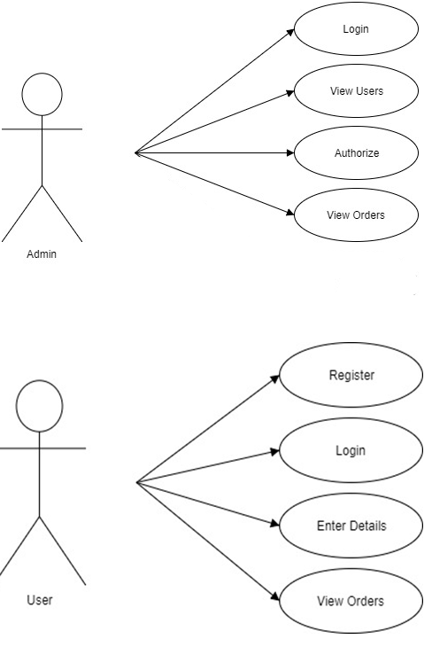

**5.2 Sequence Diagram**:

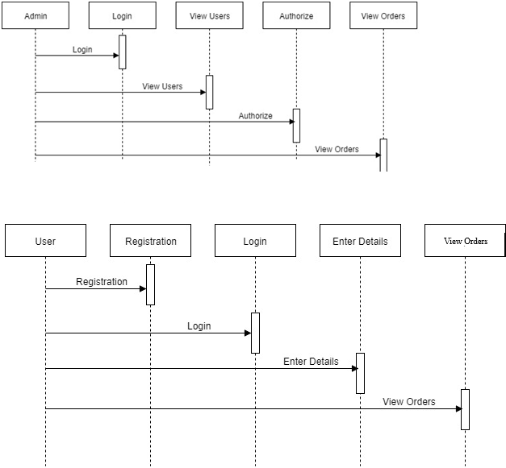

**6. SAMPLE CODE :**

* 1. **Index Page:**

This is sample code for home page, which is seen when user start the application.

<?php

session_start();

include("connection.php");

extract($_REQUEST);

$arr=array();

if(isset($_GET['msg']))

{

$loginmsg=$_GET['msg'];

}

else

{

$loginmsg="";

}

if(isset($_SESSION['cust_id']))

{

$cust_id=$_SESSION['cust_id'];

$cquery=mysqli_query($con,"select * from tblcustomer where fld_email='$cust_id'");

$cresult=mysqli_fetch_array($cquery);

}

else

{

$cust_id="";

}

$query=mysqli_query($con,"select tblvendor.fld_name,tblvendor.fldvendor_id,tblvendor.fld_email,

tblvendor.fld_mob,tblvendor.fld_address,tblvendor.fld_logo,tbfood.food_id,tbfood.foodname,tbfood.cost,

tbfood.cuisines,tbfood.paymentmode

from tblvendor inner join tbfood on tblvendor.fldvendor_id=tbfood.fldvendor_id;");

while($row=mysqli_fetch_array($query))

{

$arr[]=$row['food_id'];

shuffle($arr);

}

//print_r($arr);

if(isset($addtocart))

{

if(!empty($_SESSION['cust_id']))

{

header("location:form/cart.php?product=$addtocart");

}

else

{

header("location:form/?product=$addtocart");

}

}

if(isset($login))

{

header("location:form/index.php");

}

if(isset($logout))

{

session_destroy();

header("location:index.php");

}

$query=mysqli_query($con,"select tbfood.foodname,tbfood.fldvendor_id,tbfood.cost,tbfood.cuisines,tbfood.fldimage,tblcart.fld_cart_id,tblcart.fld_product_id,tblcart.fld_customer_id from tbfood inner join tblcart on tbfood.food_id=tblcart.fld_product_id where tblcart.fld_customer_id='$cust_id'");

$re=mysqli_num_rows($query);

if(isset($message))

{

if(mysqli_query($con,"insert into tblmessage(fld_name,fld_email,fld_phone,fld_msg) values ('$nm','$em','$ph','$txt')"))

{

echo "<script> alert('We will be Connecting You shortly')</script>";

}

else

{

echo "failed";

}

}

?>

<html>

<head>

<title>Home</title>

<!--bootstrap files-->

<link rel="stylesheet" href="https://stackpath.bootstrapcdn.com/bootstrap/4.3.1/css/bootstrap.min.css" integrity="sha384-ggOyR0iXCbMQv3Xipma34MD+dH/1fQ784/j6cY/iJTQUOhcWr7x9JvoRxT2MZw1T" crossorigin="anonymous">

<script src="https://code.jquery.com/jquery-3.3.1.slim.min.js" integrity="sha384-q8i/X+965DzO0rT7abK41JStQIAqVgRVzpbzo5smXKp4YfRvH+8abtTE1Pi6jizo" crossorigin="anonymous"></script>

<script src="https://cdnjs.cloudflare.com/ajax/libs/popper.js/1.14.7/umd/popper.min.js" integrity="sha384-UO2eT0CpHqdSJQ6hJty5KVphtPhzWj9WO1clHTMGa3JDZwrnQq4sF86dIHNDz0W1" crossorigin="anonymous"></script>

<script src="https://stackpath.bootstrapcdn.com/bootstrap/4.3.1/js/bootstrap.min.js" integrity="sha384-JjSmVgyd0p3pXB1rRibZUAYoIIy6OrQ6VrjIEaFf/nJGzIxFDsf4x0xIM+B07jRM" crossorigin="anonymous"></script>

<!--bootstrap files-->

<link href="https://fonts.googleapis.com/css?family=Lobster" rel="stylesheet">

<link rel="stylesheet" href="path/to/font-awesome/css/font-awesome.min.css">

<link rel="stylesheet" href="https://use.fontawesome.com/releases/v5.8.1/css/all.css" integrity="sha384-50oBUHEmvpQ+1lW4y57PTFmhCaXp0ML5d60M1M7uH2+nqUivzIebhndOJK28anvf" crossorigin="anonymous">

<script src="https://ajax.googleapis.com/ajax/libs/jquery/2.1.3/jquery.min.js"></script>

<link href="https://fonts.googleapis.com/css?family=Great+Vibes|Permanent+Marker" rel="stylesheet">

<script>

//search product function

$(document).ready(function(){

$("#search_text").keypress(function()

{

load_data();

function load_data(query)

{

$.ajax({

url:"fetch2.php",

method:"post",

data:{query:query},

success:function(data)

{

$('#result').html(data);

}

});

}

$('#search_text').keyup(function(){

var search = $(this).val();

if(search != '')

{

load_data(search);

}

else

{

$('#result').html(data);

}

});

});

});

//hotel search

$(document).ready(function(){

$("#search_hotel").keypress(function()

{

load_data();

function load_data(query)

{

$.ajax({

url:"fetch.php",

method:"post",

data:{query:query},

success:function(data)

{

$('#resulthotel').html(data);

}

});

}

$('#search_hotel').keyup(function(){

var search = $(this).val();

if(search != '')

{

load_data(search);

}

else

{

load_data();

}

});

});

});

</script>

<style>

//body{

background-image:url("img/main_spice2.jpg");

background-repeat: no-repeat;

background-attachment: fixed;

background-position: center;

}

ul li {list-style:none;}

ul li a{color:black; font-weight:bold;}

ul li a:hover{text-decoration:none;}

</style>

* 1. **Registration Page :**

<?php

session_start();

include("../connection.php");

extract($_REQUEST);

if(isset($_GET['product']))

{

$product_id= $_GET['product'];

}

else

{

$product_id= "";

}

if(isset($_GET['msg']))

{

$loginmsg=$_GET['msg'];

}

else

{

$loginmsg="";

}

if(isset($login))

{

$query=mysqli_query($con,"select * from tblcustomer where fld_email='$email' && password='$password'");

if($row=mysqli_fetch_array($query))

{

$customer_email =$row['fld_email'];

$_SESSION['cust_id']=$customer_email;

if(!empty($customer_email && $product_id))

{

//$_SESSION['product']=$product_id;

echo $_SESSION['cust_id']=$customer_email;

header("location:cart.php?product=$product_id");

}

else

{

header("location:../index.php");

$_SESSION['product']=$product_id;

$_SESSION['cust_id'];

}

}

else

{

$ermsg="invalid Details";

}

}

if(isset($register))

{

$query=mysqli_query($con,"select * from tblcustomer where fld_email='$email'");

$row=mysqli_num_rows($query);

if($row)

{

$ermsg2="Email alredy registered with us";

}

else

{

if(mysqli_query($con,"insert into tblcustomer (fld_name,fld_email,password,fld_mobile) values('$name','$email','$password','$mobile')"))

{

$_SESSION['cust_id']=$email;

if(!empty($customer_email && $product_id))

{

$_SESSION['cust_id']=$customer_email;

header("location:cart.php?product='$product_id'");

}

else

{

$_SESSION['cust_id']=$email;

header("location:../index.php");

}

}

else

{

echo "fail";

echo $name;

echo $email;

echo $password;

echo $mobile;

}

}

}

?>

**7. USER INTERFACE :**

**7.1 Home Page** - It consists of a navigation bar which includes About part link, Contact us part link and Services part and a slider which shows different images . It is the first page user see when he start the application.

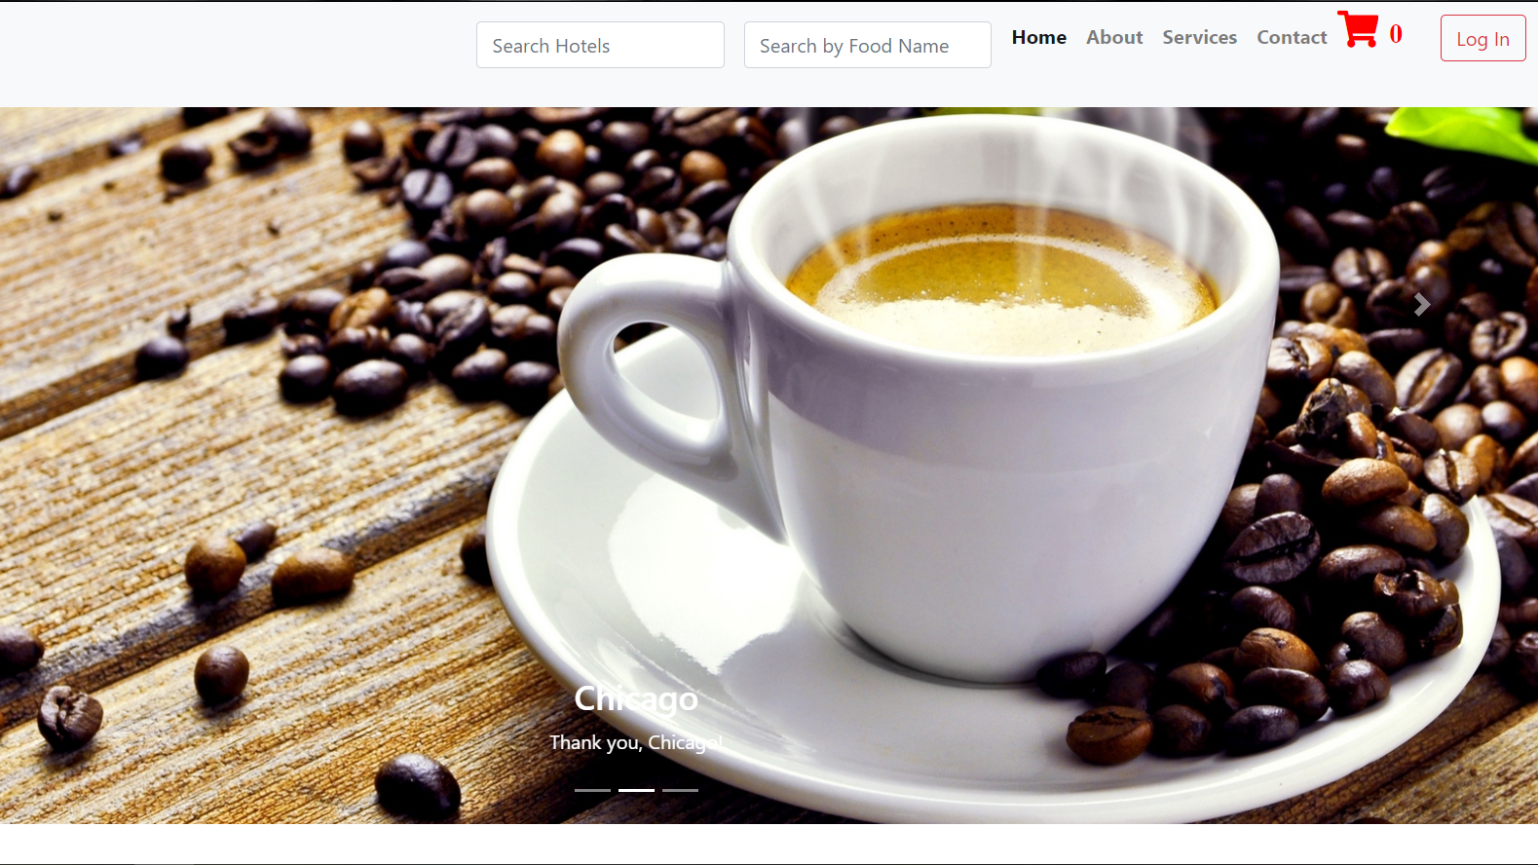

* **About-** It shows information of our location and shows some different views of the hotel.

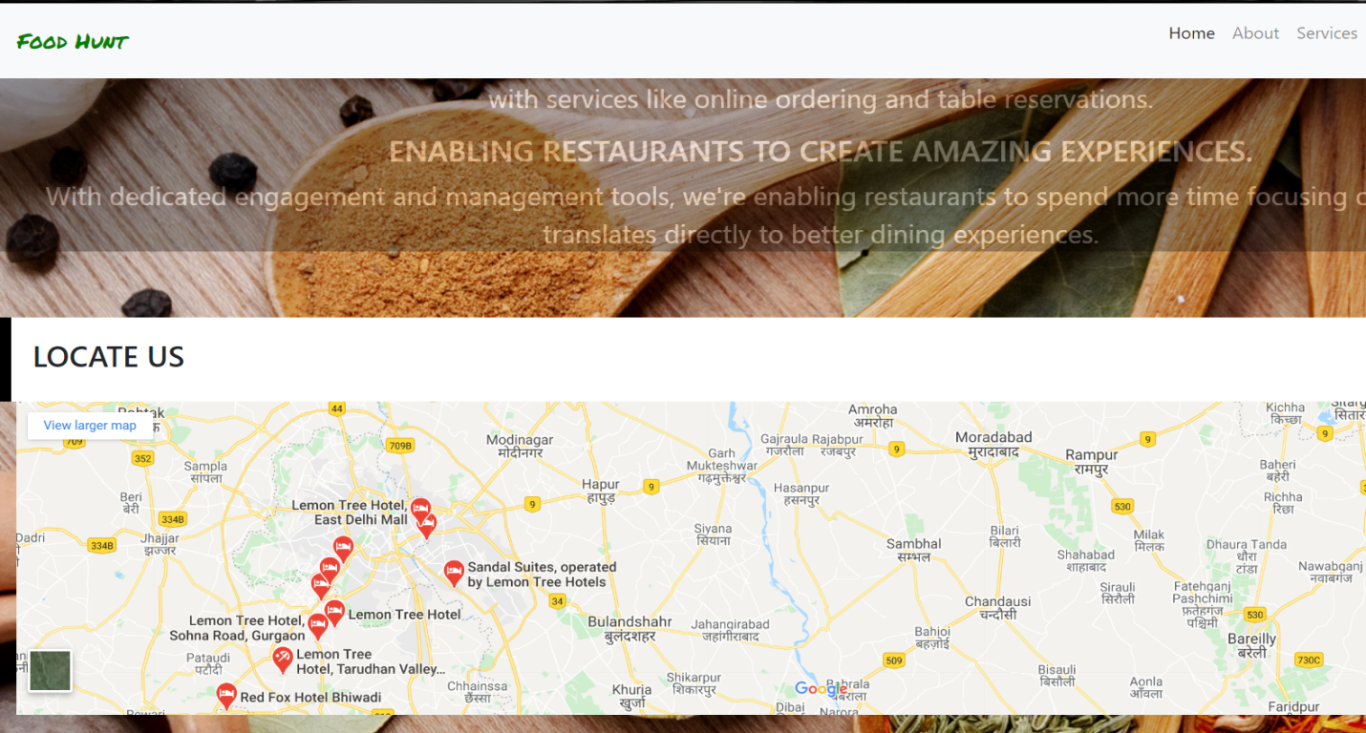

* **Contact us-** It consist a contact form .

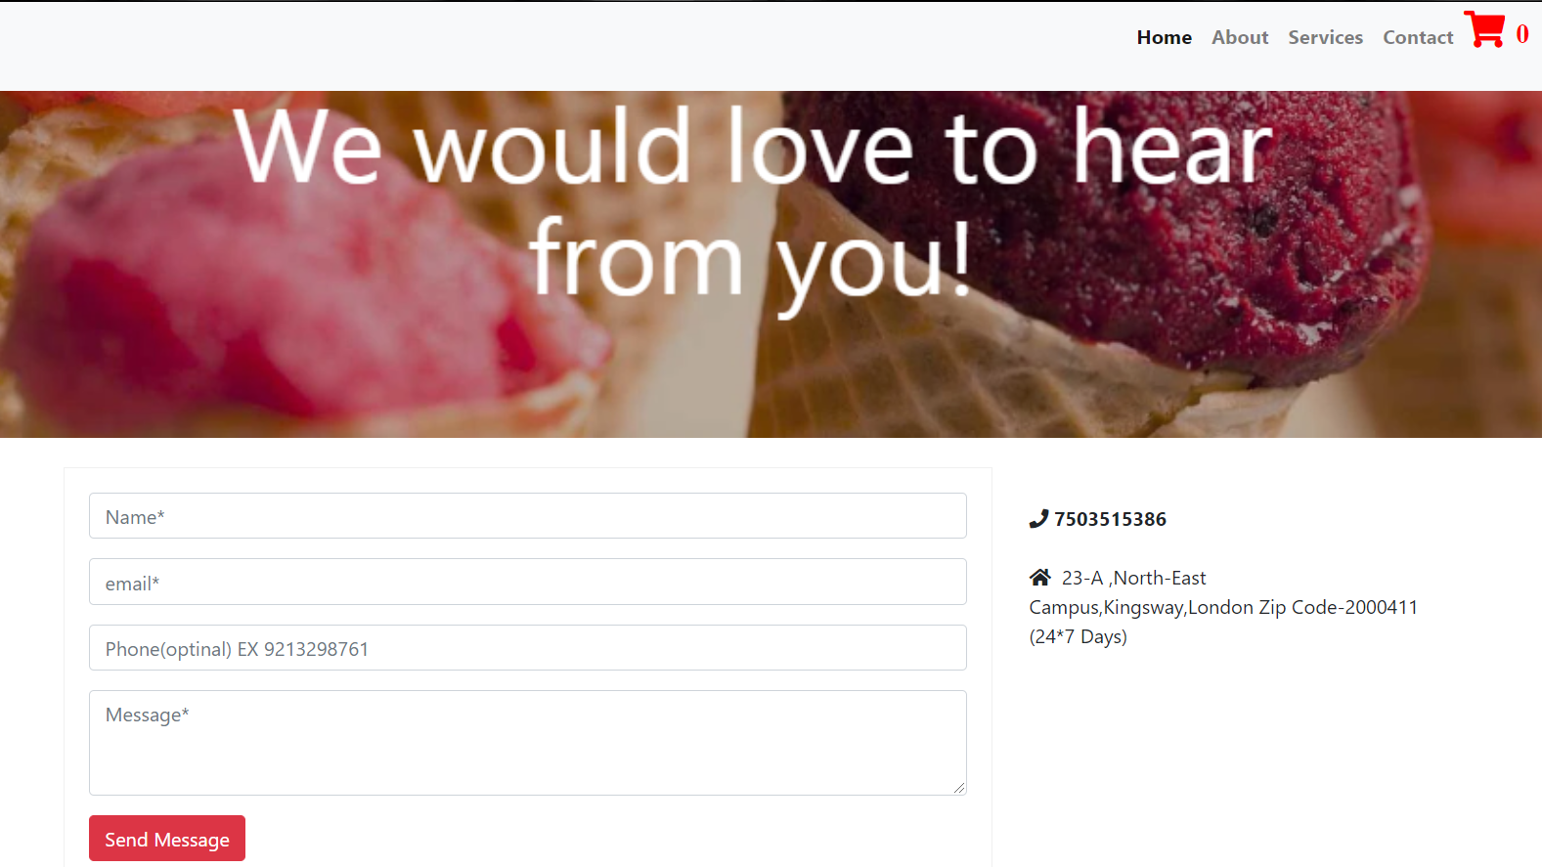

* Login Form – Form to Log in to the system.

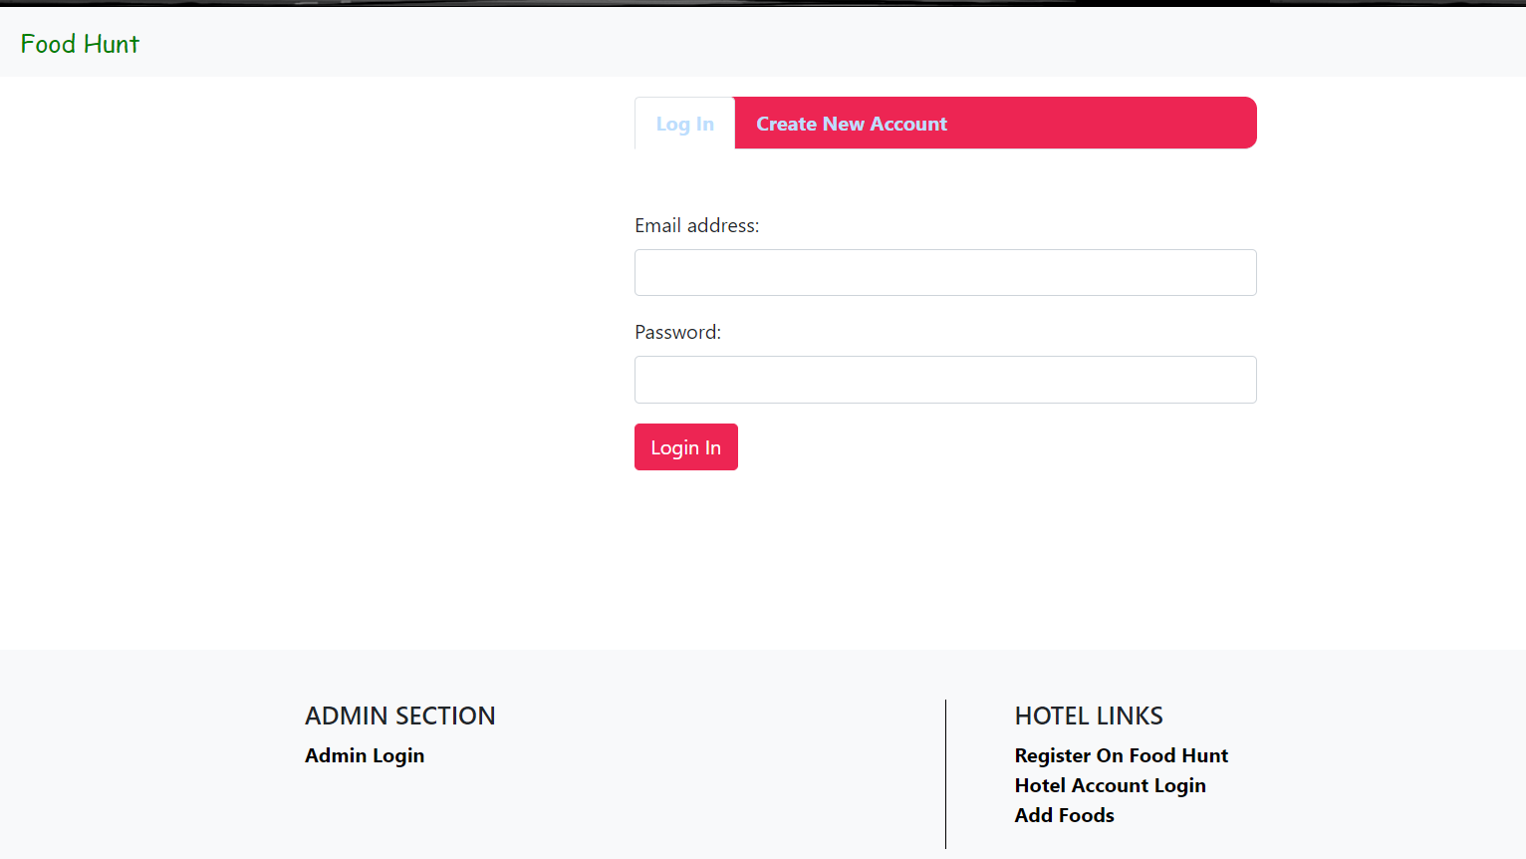

* **Registration/New Account Form –** Form for Creating a new account .

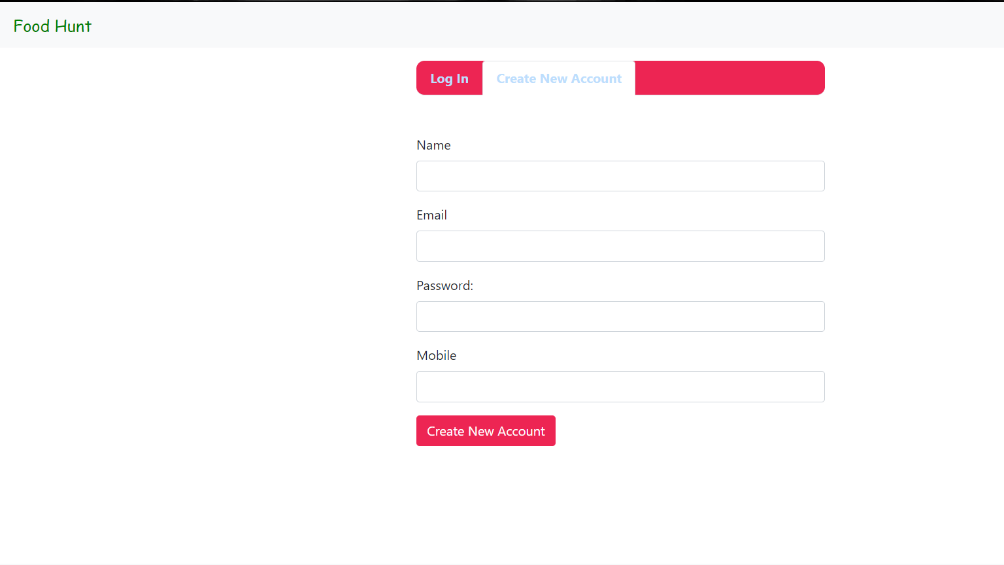

**CONCLUSION :**

After the completion of project, customer can view the overall menu of registered restaurants but cannot order any item without registration. New customer can create a new account by going on sign up page. After registration, he can login and now can add any item in any quantity in the shopping cart. He can find different category of food items as of their choice. Quantity of items can be increased or decreased . Even the customer can delete any item . The customer can place the order only through cash on delivery mode. After placing the order he can view the summary in their cart. Now restaurants have full records of their customers . For adding new restaurants , the restaurants should also have to register themselves for providing the facilities. And admin have a full access or authorisation of deleting the customer, restaurants , orders etc.

**BIBLIOGRAPHY**

* <https://www.phptpoint.com/>
* <https://www.w3schools.com/html/>
* <https://www.w3schools.com/CSS/>
* <https://www.w3schools.com/BOOTSTRAP/>
* <https://www.w3schools.com/sql/>
* <https://github.com/ayush0711/online-food-ordering-system>